BRANDING

Positioning Concept
We’re a life operating system - a dynamic command center for real-world admin and decision-making (not just storage). Automates archiving, helping with navigation, timelines visibility/generation, talking to AI. Big estate planning value-add. Marketplace/matching/grouping pieces also should be there.
Category: LifeOps (not doc storage)

Brand Essence
Emotional Promise: Clarity, control, calm
Functional Promise: All your critical data to inform better decisions, at your fingertips, 24/7
Tagline Ideation:
- Clarity in chaos. Control for life.
Quick mockup ideas:
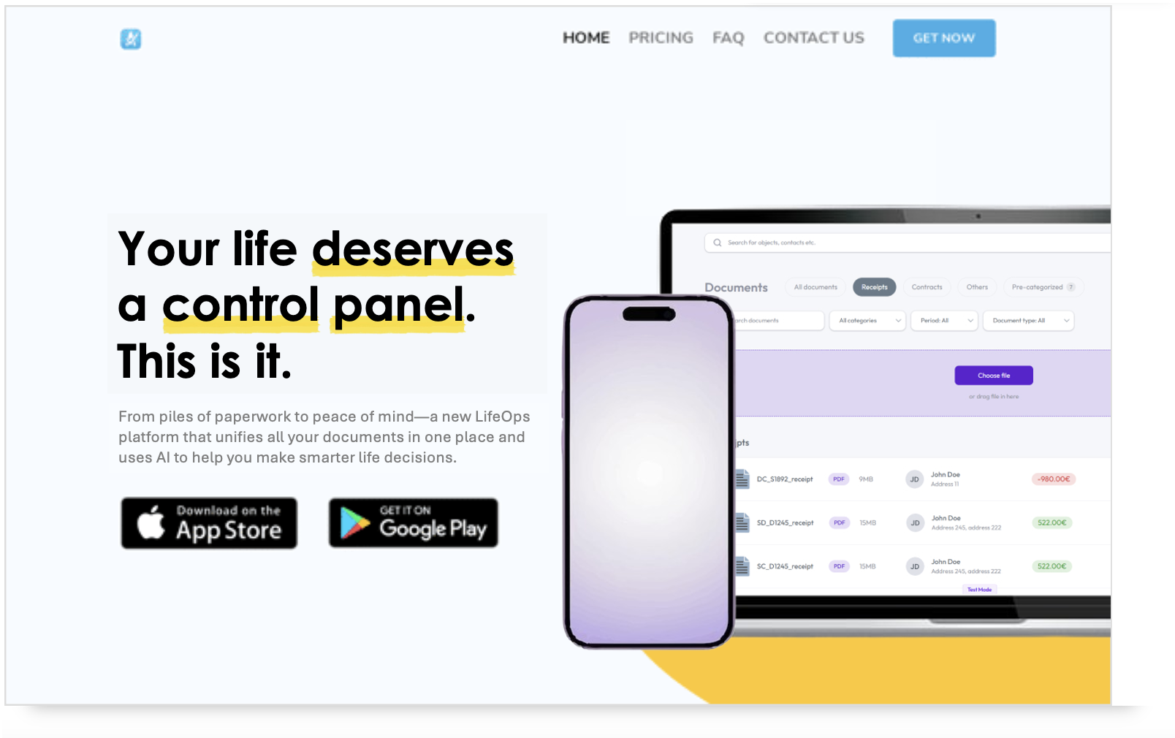
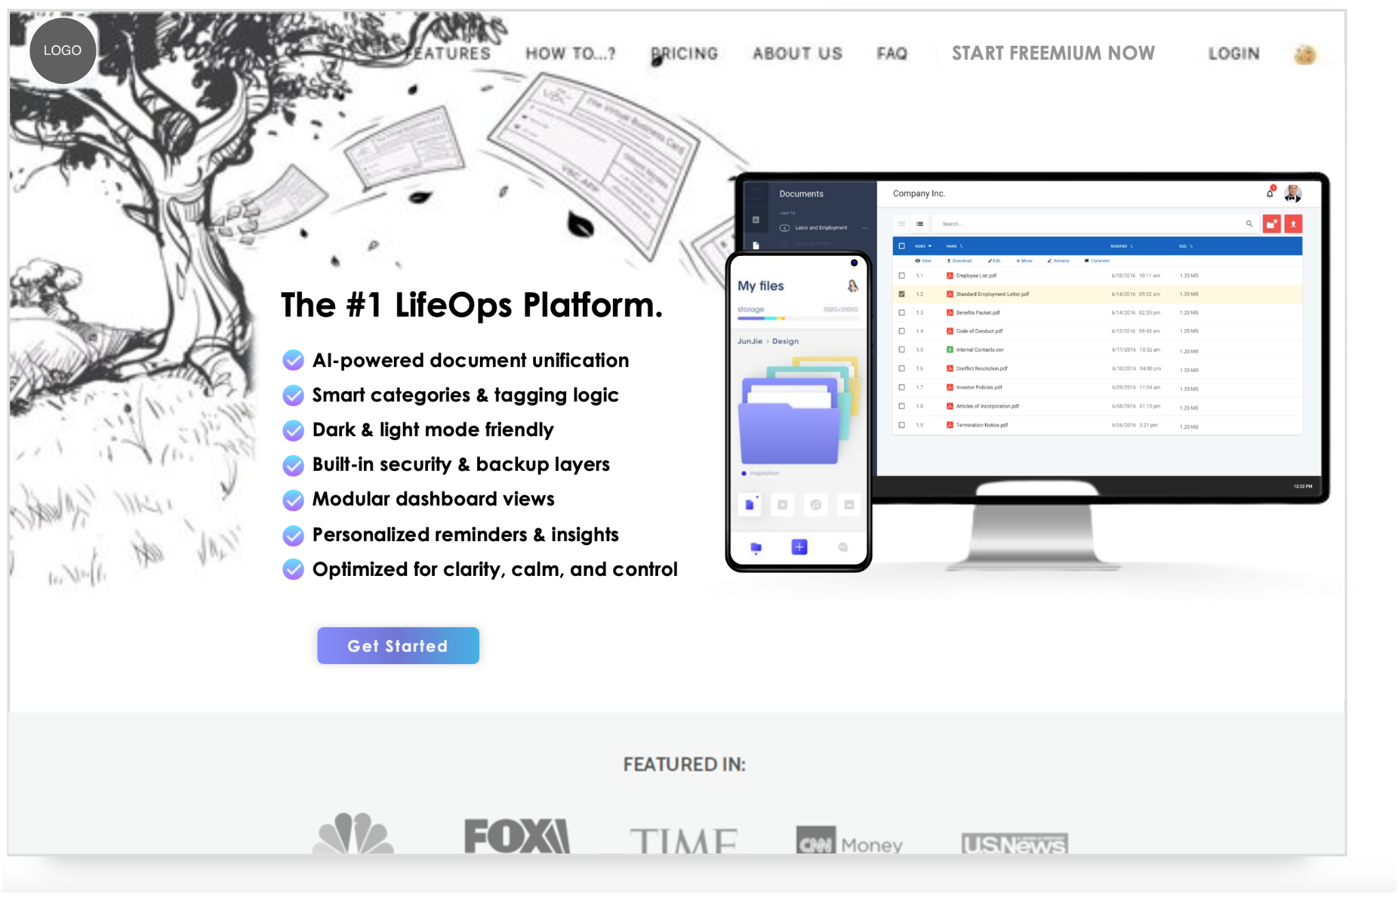
New Name Contenders:
- Ownable (.com or .ai) - Emotionally resonant and direct—this is about reclaiming ownership over your life.
- mantle - Symbolic of duty, protection, and authority. Feels like a layer of power and responsibility.
- fulcrum - Where everything pivots. Feels like the center of control—quiet strength.
- modo - Minimal and modern. Latin root for “method” or “way.” Sounds universal and adaptable.
- Syncata - Elegant fusion of synchronization and data. Has a smooth, scalable sound.
- Vaultus -
- TBD - we should ideate longer and deeper to find the ideal name
- Adminia (?)
- LifeAdmin (?)
- LifeMAP
Names to avoid or demote:
- AdminAgent / AdminOwl / DocuMap - Too on-the-nose and dated/B2B
- Filezy, Filo, Fylo - Too playful, doesn’t carry the gravitas needed
- SafeStack - Feels more like dev infrastructure

GROWTH STRATEGY (Early-Stage)

Go-to-Market Beachheads
Use these personas to narrow targeting:
1. High-performing/Busy Professionals
- Positioning: “Your life, optimized like your business
- Growth plays:
  - HQ LinkedIn carousel ad(s): “How much are you losing by not optimizing your car insurance, mortgage, etc.?”
    - Hook via ROI: Show $3K+ savings/year
Time savings + organization
2. DIY Organizers (Excel nerds & Notion users)
- Positioning: “You’ve hacked your system, now level it up with automation.”
- Growth plays:
  - Integrate with Google Drive, Notion, etc.
  - Showcase UGC of before/after systems

3. Family Stewards (estate planning/prep)
- Positioning: “Be ready when you’re needed most.”
- Growth plays:
  - Partner with estate attorneys or grief counselors
  - TikTok: Document emergency checklist content
  - Direct mail campaign to aging adult children
  - Executor of the will + beneficiaries
  - WIll require a very unique messaging + product proof to enroll these people
4. Less affluent paycheck to paycheck
- Saving them 500-1k/yr → pure financial play
- Saving $200 on car insurance, go refi that with lower interest rate
  - Homeowners, credit card optimization/cycling

TACTICAL LAUNCH IDEAS
- “10-Day Life Audit” Challenge - Get people to upload docs over 10 days in exchange for a visual “Life Health Report” (even if we have to manually create, it’s worth it). Share anonymized findings as content.
- Referral Hook - “Help your parents get organized and win a year of free service.”
- Micro-features that go viral - e.g., “Your Flood Zone Risk Score” → get people sharing bizarre clauses in their policies.
- Partner with Notion/Obsidian/YNAB creators - They have an audience primed for structure, optimization, and ownership.
- Build a real-time dashboard feature ("LifePulse" or "AdminGauge") - Make life admin feel like a credit score people can improve.
- Public Dashboard Demo (No Login) - Let prospects click through a real sample LifeMAP.
- Templates/kits - Create plug-and-play doc packs for key use cases (“The Just Married Kit”, “Parent Emergency Binder” , “Startup Founder LifeOps Pack”)

FINAL POV / NOTES
Most people don’t want to manage their admin, but they do want to feel in control. So the brand isn’t about documents. It’s about activating a feeling of clarity and calm in the face of life’s inevitable (and unseen) chaos. There’s a nagging feeling in the back of your mind that you could be more organized, but the ROI is low on doing the work to optimize.
We’re not a storage tool. We’re a LifeOps platform that lets users access a CEO dashboard for their life.

NEXT STEPS & INVOLVEMENT
This direction can unlock serious traction, both brand-wise and go-to-market.
I can help drive this forward, from name finalization to launch execution. Would love to continue the conversation around deeper involvement.

4-8 yr exit
Develop brand to get to the exit
#1 comp: https://www.quicken.com/products/lifehub/ (likely val $18-36M)
- attention + retention – plus PR
-NOT a simple solution with AI wrapper – a standalone solution

